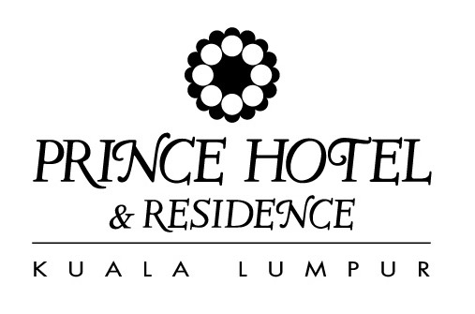

ISCA CONGRESS 2007

23-27 October 2007

ROOM RESERVATION FORM

ROOM RATE IN RM (RINGGIT MALAYSIA) – Please tick your choice

 | Deluxe Single inclusive of one (1) Buffet Breakfast | RM 280.00 nett per room/night
 | Deluxe Twin inclusive of two (2) Buffet Breakfasts | RM 305.00 nett per room/night
Smoking Non-Smoking

Note: Room rates quoted above are inclusive of 10% Service charge and 5% Government tax,
and non-commissionable.

Delegate’s Name ________________________________________________________________
Last (Family Name) First (Forename)

Company ________________________________________________________________

Business Address ________________________________________________________________
Street Address or PO Box Number
_________________________________________________________________
City State
_________________________________________________________________
Telephone Number Facsimile Number

Check-in time is after 1400hrs and check-out time is 1200hrs on day of departure. Any room occupied up till 1800hrs
will be charged at 50% of the room rate and the full day rate will apply for check-out after 1800hrs.

No bookings can be accepted without credit card details or one night’s deposit. In the event of cancellation less than
72-hours prior to the arrival date or “No-Show” for a guaranteed booking, one (1) night’s room charge plus the applicable
tax and service charges will be forfeited.

Arrival Date ________________________ Flight/ETA ______________________

Departure Date ________________________ Flight/ETD ______________________

Credit Card Type AMEX VISA DINERS MASTERS (please tick)

Credit Card No. ________________________ Expiry Date ______________________

Specimen Signature ________________________ Please advise your non-embrossed C.I.D number _________

E-MAIL OR FAX HOTEL BOOKING FORM AS SOON AS POSSIBLE

Reservation Department
Prince Hotel and Residence Kuala Lumpur
Jalan Conlay, 50450 Kuala Lumpur
Tel No : 03-2170 8888 Fax No : 03-2170 8662
Toll Free No : 1-800 888262 Email: reservations@princehotelkl.com.my

